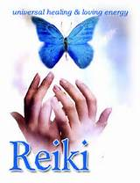
Reiki
(Pronounced Ray-Key)

Reiki treats the whole person including body, emotions, mind and spirit. Reiki energy promotes a deep sense of relaxation, relieves anxiety, accelerates healing, facilitates the relief of pain, works to heal the original cause, and assists in removing negative energy.

For a Healing, Relaxing and Restorative Reiki Experience Contact:

Joan Patchett, Reiki Master
King’s Acupuncture, 5859 Transit Rd, E. Amherst, 716-688-1768

* Special ~ $10 Off Your First Reiki Session *

